**Scheduled Instances**

Navigate to the suite Scheduled Instances dashboard.

By scheduling a particular suite in the Suites section under the Execution module user can navigate to the Scheduled Instances dashboard and also by clicking on the suite name present in the name column, the user can navigate to the Scheduled Instances dashboard.

How to Schedule a Suite?

* Hover a mouse on a particular Suite and click on more icons in the Action column to get the Schedule option.
* Click on the Schedule option.

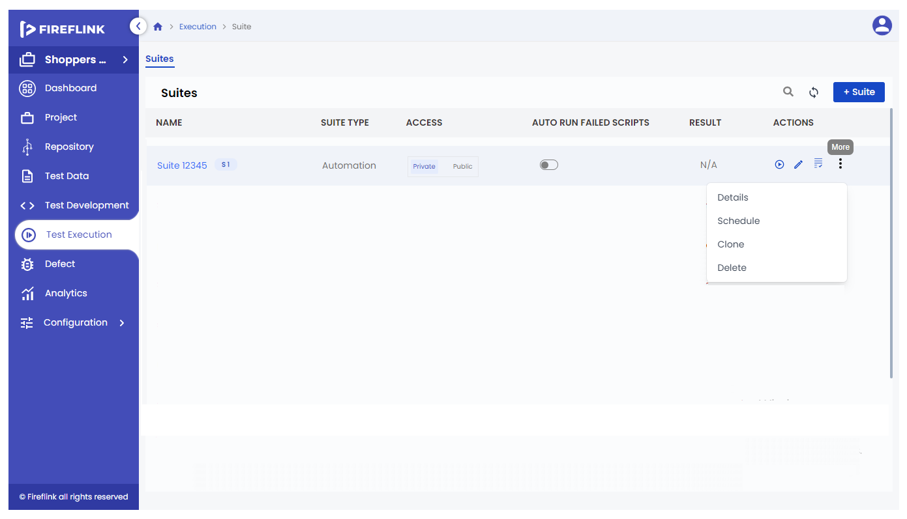

* The schedule popup is prompted.

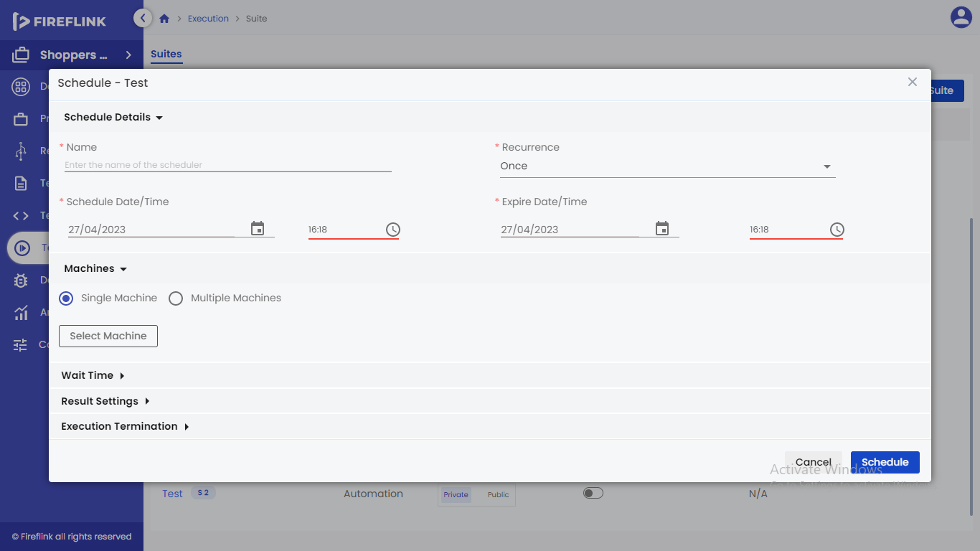

* Provide a name for the Schedule.
* By default, “once” will be selected.
* Select “Schedule Date/Time” and “Expire Date/Time”.
* Click on the “Schedule” button.

Columns under Scheduled Instances Table:

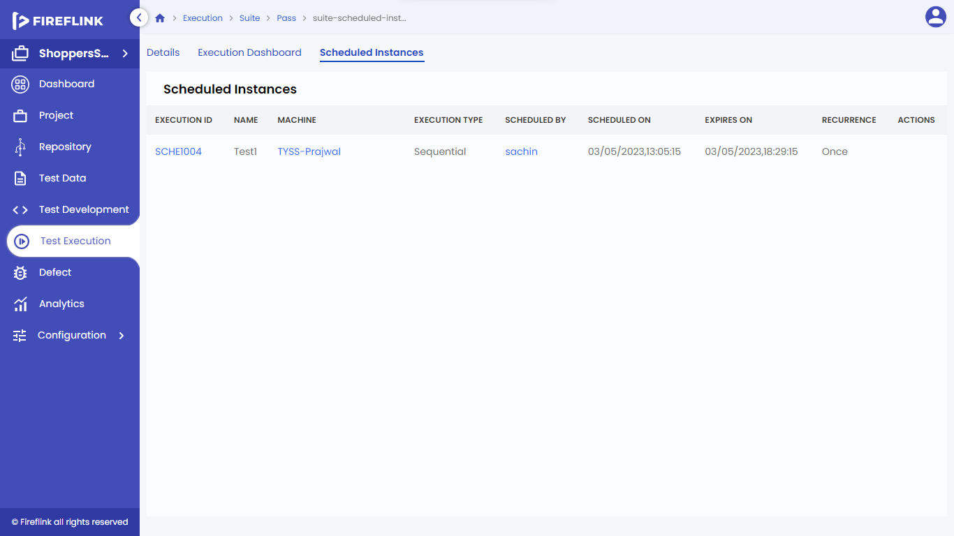

1. **Schedule Id**: Under this column, the Scheduler Id is displayed for the particular suite. Upon clicking on any schedule Id, it will navigate to the schedule id details page.

2. **Name**: Under this column name is displayed for Schedule id.

3. **Machine**: Under this column machines for the particular Suite are displayed. Upon clicking on the machine name, it will navigate to the machine details popup.

4. **Execution Type**: Under this column, the Execution type for the particular suite is displayed.

5. **Scheduled By**: Under this column, scheduled by user name is displayed. In this column, scheduled by implies the user name who has scheduled the suite. Upon clicking on the user name, it will navigate to the user details popup.

6. **Scheduled On**: Under this column, Scheduled On details like date and time are displayed.

7. **Expires On**: Under this column, Expires On details like date and time are displayed.

8. **Recurrence**: Under this column, recurrence details of the particular scheduled id are displayed.

9. **Actions**: Under this column, on hovering the mouse on Schedule Id, the “Reschedule” and “Delete” icons are displayed.

9.1 **Reschedule a Suite**:

* Hover a mouse on a particular schedule id and click on Reschedule icon in the Action column.

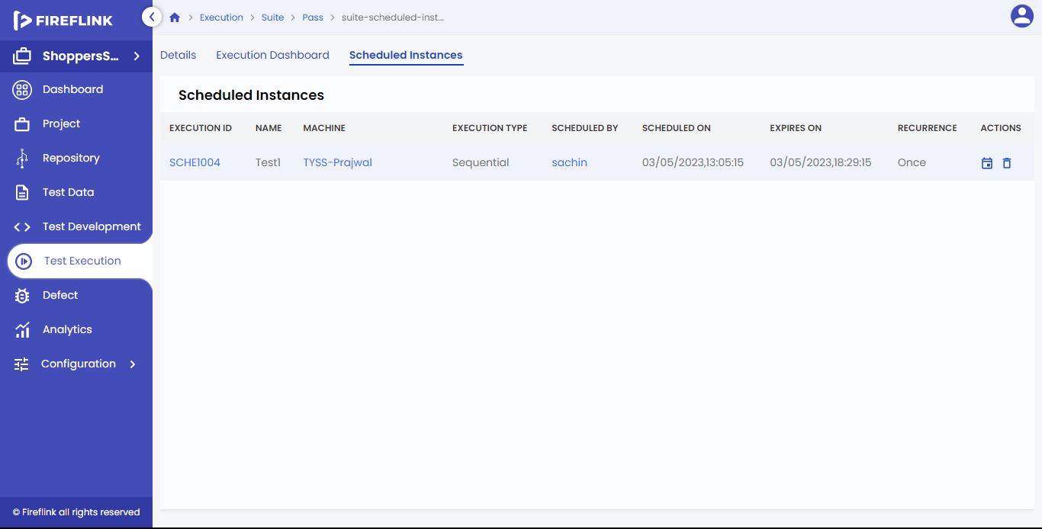

* Reschedule popup is prompted as shown below.

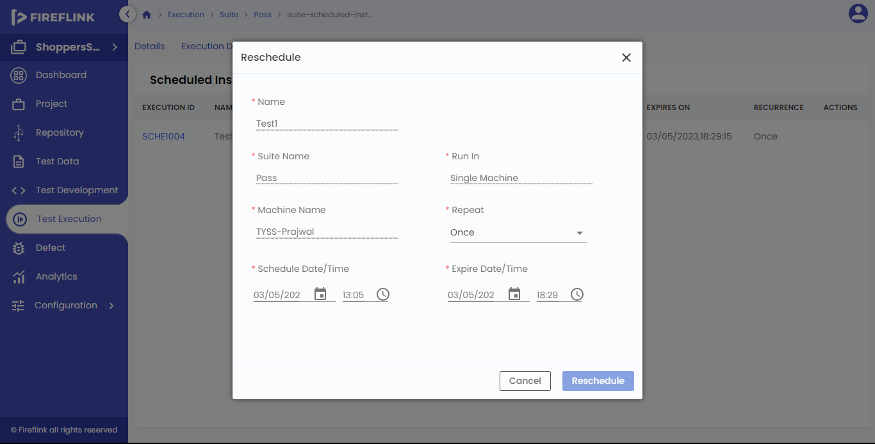

* Select the “Repeat” option, by default the previously selected value is displayed.
* Select “Schedule Date/Time” and “Expire Date/Time” to reschedule.
* Click on the “Reschedule” button.

Delete Scheduled Instances

* Hover a mouse on a particular schedule id.
* Click on the “Delete” option.

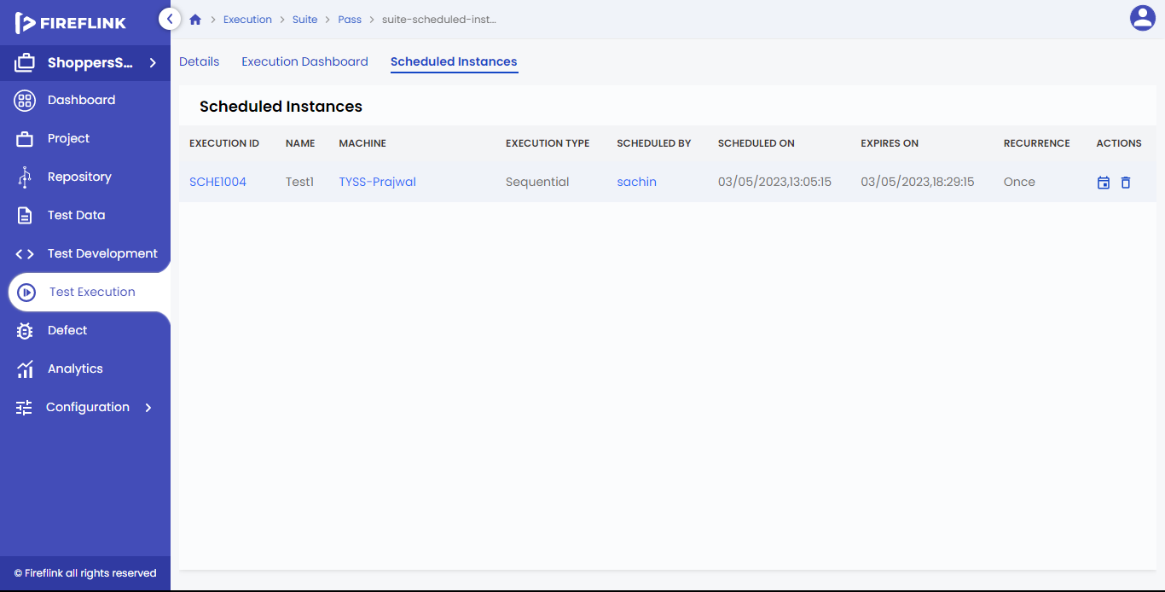

* A warning popup will be prompted.

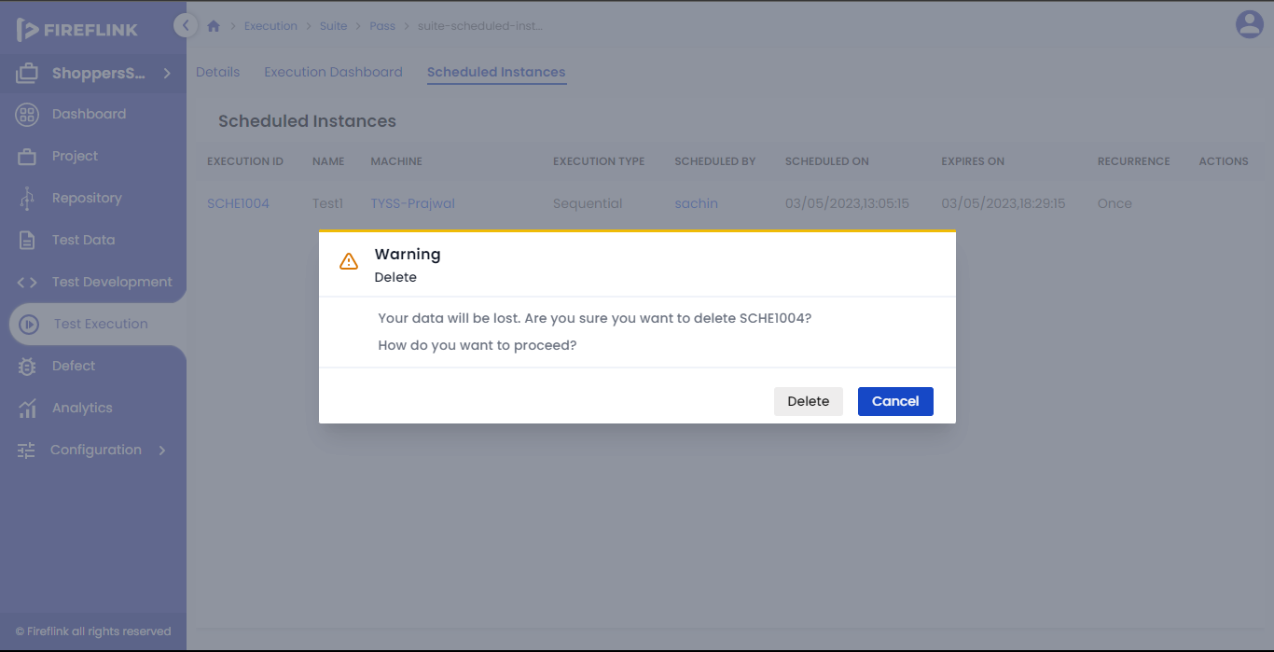

* Click on the “Delete” button to delete the schedule id permanently.

**How to see the schedule Id details?**

Click on the particular schedule Id present in the schedule Id column to see the schedule Id details on the page.

**How to see the machine details?**

Click on the machine name present in the machine column to see the machine details in the popup.

**How to see the Scheduled by details?**

Click on the user name present in the scheduled by column to see the user details in the popup.